CHAPTER FOUR
DEVELOPMENT OF NEURAL NETWORK BASED SIGNATURE RECOGNITION SYSTEM

4.1 Overview

It is often useful to have a machine performing pattern recognition. In particular, machines that can read symbols are very cost effective. A machine that reads banking cheques can process many more cheques than a human being at the same time. This kind of application saves time, money, and eliminates the requirement that a human perform such a repetitive task. In this chapter the computer modeling of signature recognition system is implemented steps of modeling are described.

4.2 Introduction

In recent years there have been two kinds of attempts towards the development of shape recognition algorithms: generic techniques which may be used for recognizing any shape in a dynamic environment; and specific techniques which may be used for a limited set of shapes. Generic techniques are more difficult to implement since the amount of noise, nature of data and measurement methods vary significantly across different applications. However their prime advantage is that they can be applied in a range of situations and in various environments. Since the application data differs across applications, generic techniques cannot rely on feature databases which can only hold finite templates. Rather they utilize computational methods such as neural networks which can learn shapes from the available data. Since generic techniques do not incorporate template matching algorithms, the recognition rates are in most cases lower than those obtained by using specific methods.

Specific methods of shape recognition are developed especially for specific applications. As an example, high quality signature recognition systems are required for the market viability of OSR systems. Such systems need very high recognition rates and work with a fixed amount of signatures. It is therefore possible to devise feature vectors for these shapes which may be stored in a database for comparison with the actual shape under consideration. The most common method of determining the class of a new shape is to compute feature vector differences between the new shape and the stored signature templates. If the mean squared difference between the feature vector of stored template and the new image scanned is below the threshold limit set, the stored template is chosen as representing the shape under consideration.

Signature recognition systems have become popular over the last decade. Recent developments in reducing the cost of hardware and fast processing have significantly enhanced their marketability. In accordance with their widespread need, researchers have applied sophisticated recognition techniques including Quadratic Discriminate Analysis for Signature recognition.

This chapter proposes a generic method of shape analysis - String Distance Measurement (SDM). The technique is supposed to be generic in the sense that it can be applied to a variety of applications and improved in a number of ways to suit particular applications. The technique is significantly different than conventional pattern matching techniques and SDM can only be used by converting a gray scale image into a binary image. In order to be generic, there were two important objectives while formulating the technique. Firstly, SDM features have to be independent of the specific aspects of individual shapes such as thickness of line, size of Signature/shape, etc. Secondly, the technique should be, to a moderate extent, resistant to the dynamic environmental influences during image acquisition such as improper lighting, uncertainty and impreciseness in data, low resolution, and other factors which vary across applications.

This chapter also describes the SDM methodology, verify the usefulness of the technique by presenting the results of a cross-validation study by using a Neural Network for recognizing a set of Signatures, and discuss how the results can be further improved.
4.3 Quantifying Gradient Change in Images

The majority of the generic shape recognition methods rely on using the topological features of an image. SDM quantifies the property of gradient change as the shape changes.
The 16 level gray scale image obtained (in this study) is initially converted into a binary image by assigning every pixel value equal to or greater than 128 a value 1 and all others a value 0. The source image is skeletonized and divided into nine segments containing equal number of pixels. For each segment, its SDM feature is calculated.

The set of rules employed can be summarized below.

Rule 1. The whole process proceeds in a horizontal manner, row by row. At any one
time, two successive rows are under consideration.

Rule 2. The process continues unless all rows of the image pixels have been exhausted.
Start with the first row.

Rule 3. Let’s call the black pixel found in row i as Bi.

Rule 4. Find the distance between Bi and Bi +1. Lets say the distance is Si .

Rule 5. Sum up all the distances for a total of k rows,; SD is the String
Distance for the whole segment.

This is shown in figure 4.1 below with two examples illustrating positive and negative SDs.

0
1
0
1
1
0
1
0
1
0
-6
-5
-4
-2
0
SD = -6
Downward Pass
1
1
+4
1
+2
1
+3
0
1
0
0
SD = +6
Downward Pass
0
1
0
+6
(a)
(b)

Figure 4.1 SD Calculations. (a) (Negative Values); and (b) (Positive Values)

SD represents the change in gradient as we traverse in downward direction which is summed up by considering any two adjacent rows at any one time. SDs is calculated for each of the nine segments. The overall procedure is described in the next section.
From figure 4.1 (a) and (b), it is evident that SDs may have a zero value if the figure 4.1 (a) and (b) shapes coexist in the same segment. Hence multidirectional lines will contribute differently (positive and negative values) to the summed measurement.
Also single horizontal and vertical lines will have zero SD values. This may be shown below in figure 4.2 (a) and (b).
1
1
1
1
1
1
1
1
1
1
1
1
0
0
SD = 0
SD = 0
1
1
1
1
1
1
1
1
1
1
1
1
0
-1
-2
+2
+1
0
+1
+2
-1
-2
(b)
(a)

Figure 4.2 SD Computations (Zero Values) for (a) and (b)

The SD computation can be summarized as: (when looking from the right hand side) Positive for convex shapes, Negative for concave shapes, and Zero for shapes which are symmetrical around the x or y axis. However it is needed to include the extent of horizontal and vertical lines which are not properly measured by SD alone. Another parameter called String Line Measurement (SLIM) is therefore introduced. SLIM has a value 1 if a horizontal or vertical line is detected, otherwise it is 0. This SLIM value must be scaled to the SD measurement before it can be added to it. Also SLIM values must be modified to represent the contribution of longer lines as greater to the overall SDM value. This can be achieved by taking into consideration the total number of black pixels in the straight horizontal or vertical lines with respect to the total number of black pixels in the segment. The final equation used for the string distance measurement of segment i with a total of n V/H (vertical or horizontal) segments is in equation (4.1) below.

(4.1)
Where
α factor_{i} = SD_{i}
β_{j} factor_{i} = SD_{i} * (SLIM_{j} * Black Pixels within V/H segment_{j})/(Black Count_{i})
Here Black Count represents the total number of black pixels within the individual segment (one of the nine) under consideration. Horizontal and Vertical scans were separately needed for each segment for identifying horizontal and vertical lines. If there is more than one black pixel in a row or a column, it indicates the presence of a horizontal or vertical line segment. Longer horizontal or vertical segments yield a higher value for the β factor and increase the overall value of SDM.

4.4 SDM Analysis

The overall analysis can be divided into three stages: image acquisition and preprocessing, feature extraction, and neural network analysis. 10 people were asked to sign. It was not necessary that the image should touch the box boundary as it was clipped later on. The image was picked up using tablet PC.
The patterns obtained were used as inputs to the neural network for recognizing different Signatures. The overall process can be shown in figure 4.3 with the following flowchart.

Source Image
Skeletonize
Clip image
Calculate SDM
Neural Network Analysis
Input
Output

Figure 4.3 Flowcharts for Methodology

4.4.1 Image Database (Source Image)

The starting point of thesis was the creation of a database with all images that would be used for training and testing (Appendix A). The image database can have different formats, but the images in this thesis are .jpg format by Adobe Photoshop program as shown in Figure 4.4, This means that they have same sizes and same resolutions, and then the value of the signatures images pixel taken after the gray scaling and clip image stages as shown in Figure 4.7, and combination in target1.dat file acting as a database for the program Examples of signatures are shown in Fig. 4.4.

Raed
Jebreel
Ahmad
Shaher
Zaed
Ali
Anwer
Osama
Yaser
Samer

.

Figure 4.4 DATABASE Fragment

Figure 4.4 shows the database of the Signatures before applying any procuring.

4.4.2 Grayscale Factor

A grayscale image is simply one in which the only colors are shades of gray.
The reason for differentiating such image from any other sort of the color image is that less information needs to be provided for each pixel. In fact a gray color is one in which the red, green, and blue components all have equal intensity in RGB space, and it is necessary to specify a single intensity value for each pixel, as opposed to the three intensities needed to specify each pixel in all color images. Often, the grayscale intensity stored as an 8-bit integer giving 256 possible different shades of gray from black to white.
Grayscale images are very common, in part because much of today’s display and images capture hardware can only support 8-bit images. In addition, grayscale images are entirely sufficient for many tasks so no need to use more complicated and harder to process color images.

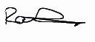
Image (a)
Image (b)

Figure 4.5 Grayscale of (RAED) Signature

Figure 4.5 Image (a) shows that (RAED) Signature colored image, where after applying the grayscale the result became like Image (b) which is grayscale image.

4.5 Skeletonize

The image was first skeletonized. The skeleton was obtained by making use of a conditional erosion algorithm which eroded the original image with four successive passes: from left, right, up and down, using the condition: “erode if (next pixel is black) and (one or more surrounding pixels are black)”. The process continued until the image could no longer be eroded.
The skeletonized image can be shown in figure 4.5 below.
0,0
0,1
0,2
1,0
1,1
1,2
2,0
2,1
2,2
0,0
0,2
1,0
1,2
1,3
2,0
2,1
2,2
(a)
(b)

Figure 4.5 Skeleton Image for (a) “a”; (b) “d”.
Image recognition software was developed which segments the image and analyzes the partitioned segments individually. It can be seen from Figure 4.5 (a) and (b) that SDM values for different segments will be vary across different images, e.g. for figure 4.5(a) segment (0, 0) it has a negative value, but it is nearly zero for the same segment in figure 4.5(b).

Then the image was segmented in 9 parts as shown in figure 4.6, each segment with its own binary address. The features (SDM values) were extracted for each segment and the complete image was described with a nine component vector S = (SDM1, SDM2 ... SDM9). In practice although for two different images, a few of the segments may yield identical SDM values, it would be rare if all the nine values were same for completely different shapes.





Figure 4.6 Signatures after Segmentation

Figure 4.6 Shows the signatures after applying Segmentation stage.

4.6 Clip Images

The resultant image was clipped so that the edges of the image were confined within a fixed boundary.
Clipping is defined as the decrease or reduction of the image size by a fixed ratio. Clip image is like a reversal of the process of enlargement, so first of all we smooth the images by convolution with a spatially resolution. However, for clip image by specific factor in the respective directions, the used factor hear are hig=20; len=50; of the original image, so the image length to height ratio of the reduced result remains equal to that of the original image length to height ratio.

Figure 4.7 Signatures Clipped (Resized)

Figure 4.7 Clip Images of the grayscale signatures

4.7 Problem Statement

A network is to be designed and trained to recognize the 10 signatures. An imaging system that digitizes each signature centered in the system’s field of vision is available. The result is that each signature is represented as an image.
Perfect classification of ideal input vectors is required and reasonably accurate classification of noisy vectors. The target is also defined in this file with a variable called target. Each target vector is a 20-element vector with a 1 in the position of the signature it represents, and 0’s everywhere else.

4.8 Neural Network

The network receives the 400 Boolean values as a 400-element input vector. It is then required to identify the signature by responding with a 20-element output vector. The 16 elements of the output vector each represent a signature. To operate correctly, the network should respond with a 1 in the position of the signature being presented to the network. All other values in the output vector should be 0. In addition, the network should be able to handle noise. In practice, the network does not receive a perfect Boolean vector as input. Specifically, the network should make as few mistakes as possible when classifying vectors with noise of mean 0 and standard deviation of 0.2 or less.
4.9 Architecture

The neural network needs 400 inputs and 16 neurons in its output layer to identify the signatures. The network is a two-layer log-sigmoid/log-sigmoid network. The log-sigmoid transfer function was picked because its output range (0 to 1) is perfect for learning to output Boolean values.

IW_{1,1}
b¹
20
1000
1
x1
16x1000
16x1
P¹
+
n¹
10
x1
b²
LW_{2,1}
a²=y
a¹
10x1
20x10
20x1
1
n²
+
20x1
20x1
Output Layer
Input
Hidden Layer
a¹=logsig(IW_{1,1}P¹ + b¹)
13
a²=logsig(LW_{2,1}a¹ + b²)

Figure 4.8 Neural Network Architecture

The hidden (first) layer has 16 neurons. This number was picked by guesswork and experience. If the network has trouble learning, then neurons can be added to this layer. The network is trained to output a 1 in the correct position of the output vector and to fill the rest of the output vector with 0’s. However, noisy input vectors may result in the network not creating perfect 1’s and 0’s. After the network is trained the output is passed through the competitive transfer function compete. This makes sure that the output corresponding to the letter most like the noisy input vector takes on a value of 1, and all others have a value of 0. The result of this post-processing is the output that is actually used.

4.10 Initialization

The two-layer network is created with _{newff.} As shown in figure 4.9

T=target1;
S1 = 16;
[R,Q] = size(pi);
[S2,Q1] = size(T);
P = double(P);
net = newff(minmax(P),[S1 S2], {'tansig','purelin'},'traingdx');
T=target1;
S1 = 16;
[R,Q] = size(pi);
[S2,Q1] = size(T);
P = double(P);
net = newff(minmax(P),[S1 S2], {'tansig','purelin'},'traingdx');

Figure 4.9 Network Initialization

4.10.1 Training without Noise

The network is initially trained without noise for a maximum of 10000 epochs or until the network sum-squared error falls beneath 0.01. P = double (P) as shown in figure 4.10

T = target1;
net.trainParam.show = 20;
net.trainParam.lr = 0.04;
net.trainParam.lr_inc = 1.04;
net.trainParam.epochs = 10000;
net.trainParam.goal = 0.02;
[net,tr]=train(net,P,T);

Figure 4.10 Training without Noise

4.11 System Performance

Signature recognition uses a large (but simple) three-layer neural network to learn and recognize pattern (Input, Hidden, and Output layer). The signature image is digitized onto a grid of input neurons as shown in figure 4.11. The output of the input neurons are input of the hidden layer, each possible answer is represented by a single output neuron. As in most networks, the data is encoded in the links between neurons.
I_{1.1}
I_{1.2}
I_{1.3}
I_{1.4}
I_{1.9}
I_{1.10}
I_{2.9}
I_{2.10}
I_{2.1}
I_{2.2}
I_{2.3}
I_{2.4}
I_{20.1}
I_{20.2}
I_{20.3}
I_{20.4}
I_{10.9}
I_{10.10}
I_{1.1}
I_{1.2}
I_{1.3}
I_{10.9}
I_{10.10}

Figure 4.11 Digitize Image into a grid of input neurons.

After the neuron in the first layer received its input, it will apply the linear combiner and the activation function to the inputs and produce the hidden input. This hidden input, as we will see in figure 4.12, will become the input for the neurons in the next layer.

I_{1.1}
I_{1.2}
I_{1.3}
I_{10.9}
I_{10.10}
H₁
H₂
H₃
H₁₆

Figure 4.12 Input-Hidden Layer Feed-Forward Connections

After the neuron in the hidden layer received its input, it will apply the linear combiner and the activation function to the inputs and produce the hidden output. This hidden output, as we will see in Figure 4.13 will be the input for the neurons in the next layer (Output layer).


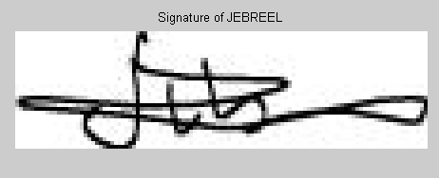

H₁
H₂
H₁₆
O₁
O₂
O₁₀₀
Raed’s signature

Jebreel’s signature

Samer’s signature

Figure 4.13 Hidden-Output Layer Feed-Forward Connections

Output of the neurons will be match with the different types of the network and it will identify whether it is Raed’s signature, Jebreel’s signature, and so on up to last signature as shown in figure 4.14 & 4. 15.

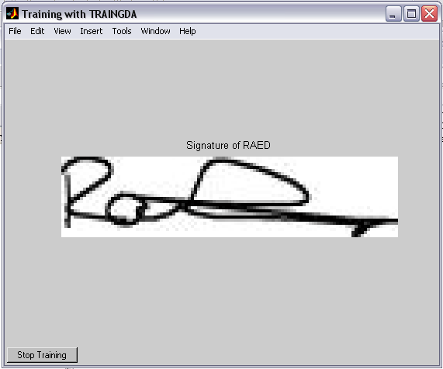

Figure 4.14 The final result (Raed’s signature)

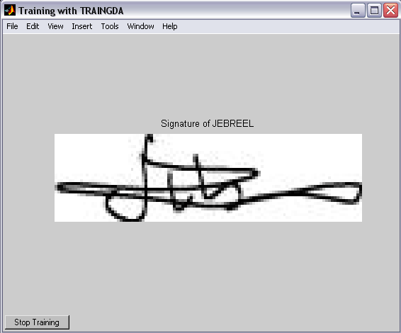

Figure 4.15 The final result (Jebreel’s signature)

4.12 Noisy Pattern Generalization

Using developed neural signature recognition system, the recognition of noisy signatures recognition has been studied. The type of noise added to the signatures was the salt and pepper noise (0.2) shown in Figure 4.16

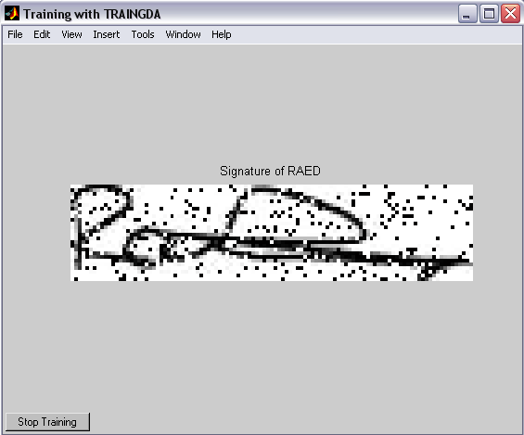

4.16 The result of noisy signature

4.13 Results of Comparison

Comparing the results with those in reference [22], the proposed system has the following results as shown in Table 4.1

Table 4.1 Testing results of the signatures

Test No. | Learning Rate | Maximum Epochs | Reached Epochs | Performance goal | Goal
1 | 0.04 | 10000 | 7511 | 0.00999948 | Met
2 | 0.037 | 10000 | 3864 | 0.00999687 | Met

Figures 4.17 & 4.18 show the training performance.
Figure 4.17 Test No. 1

Figure 4.18 Test No. 2

The obtained recognition for 10 signatures has high accuracy and tabulated in table 4.2.

Table 4.2 Signatures recognition accuracy for 10 signatures

 | Accuracy
Noisy | 98.6%
Non-noisy | 99%

Table 4.3 Signature Recognition Accuracy of Hidden Markov Models (HMM) & NN

 | Hidden Markov Models (HMM) | Neural Network
Recognition rate | 93% | 99%

The simulation result of Neural Network based Signature Recognition is compared with the result of system based on Hidden Markov Models (HMM) described in [22]. It was obtained that Neural Network based Signature Recognition has more accuracy than the other one. Comparative simulation results of these systems are given in Table 4.3. Obtained results satisfy the efficiency of developed neural Network based Signature Recognition.

4.14 Summary

In this chapter the principles of development of signature recognition system are given. Generic method of shape analysis- String Distance Measurement technique is described; SDM analysis of image is given. Using image database the steps of recognition have been explained. MATLAB program used to solve problem of signature recognition, and stages of the program are described.

